Tommy Biard

BIT 113 – USER INTERFACE DEVELOPMENT

Professor Bansenauer

10/30/2018

**Photos Licenses**

1. Friends of North Creek Forest Logo
   1. Permission from Client
   2. Pictures Used
      1. <https://www.friendsnorthcreekforest.org/uploads/6/8/5/3/6853956/published/fncf-rgb-horizontal-logo_1.jpg?1536794208>
         1. 
2. PEXELS
   1. CC0 License
   2. ✓ Free for personal and commercial use
   3. ✓ No attribution required
3. Pictures Used
   * 1. <https://www.pexels.com/photo/adorable-animal-bloom-blossom-416070/>
        1. adorable-animal-bloom-416070.jpg
        2. 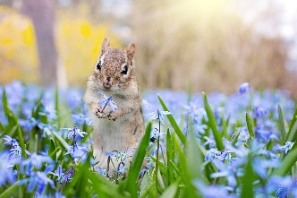
     2. <https://www.pexels.com/photo/nature-animal-park-birds-33101/>
        1. animal-animal-photography-bird-33101.jpg
        2. 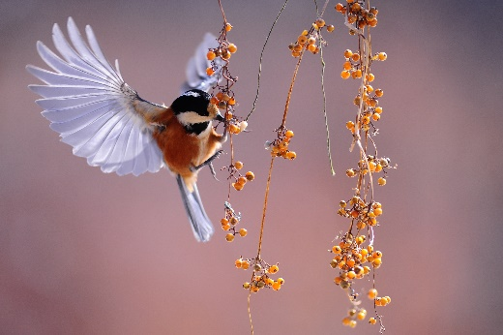
     3. <https://www.pexels.com/photo/close-up-photography-of-a-butterfly-672142/>
        1. animal-biology-blur-672142.jpg
        2. 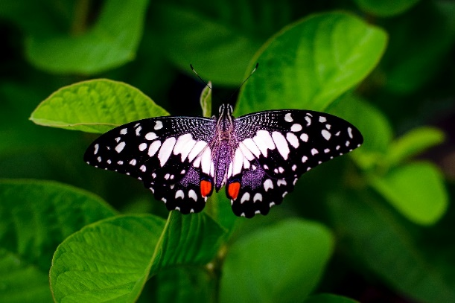
     4. <https://www.pexels.com/photo/water-drops-reflection-1557853/>
        1. ball-shaped-blur-close-up-1557853.jpg
        2. 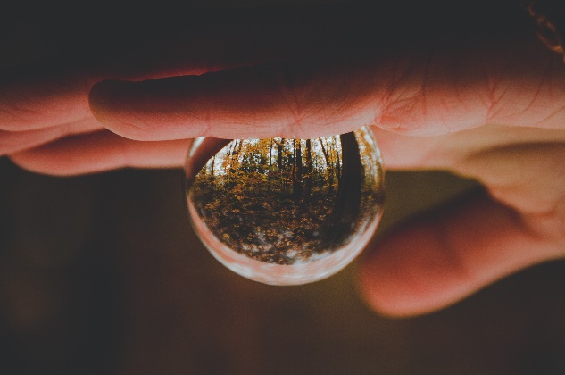
     5. <https://www.pexels.com/photo/sunset-on-rain-forest-1125776/>
        1. forest-grass-green-1125776.jpg
        2. 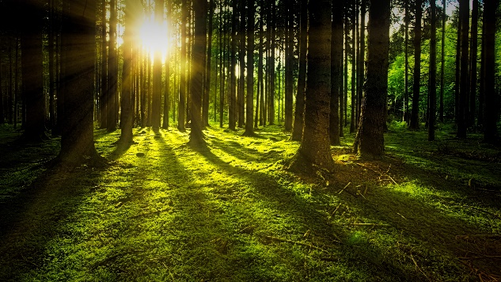
     6. <https://www.pexels.com/photo/bubbles-chemistry-close-up-color-220989/>
        1. bubbles-chemistry-close-up-220989.jpg
        2. 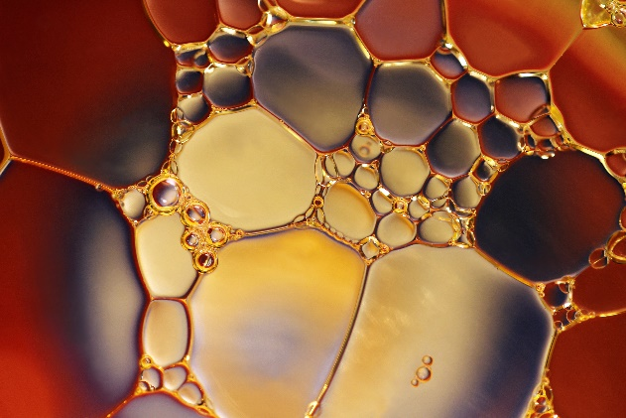
     7. <https://www.pexels.com/photo/autumn-autumn-leaves-background-blur-459620/>
        1. autumn-autumn-leaves-background-459620.jpg
        2. 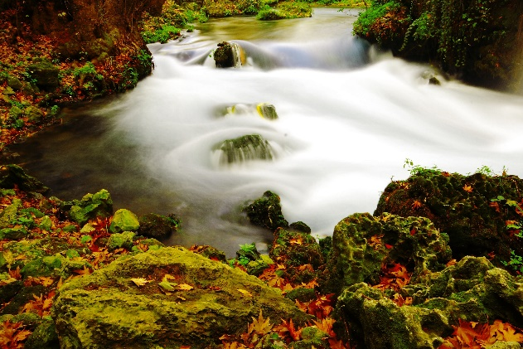
     8. <https://www.pexels.com/photo/animal-animal-photography-animal-world-blur-531288/>
        1. animal-animal-photography-animal-world-531288.jpg

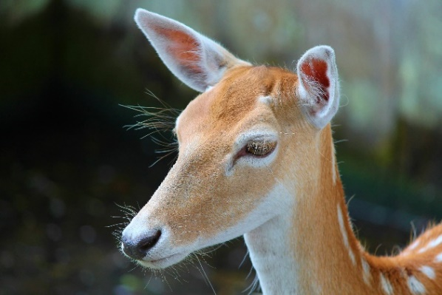

* + 1. <https://www.pexels.com/photo/close-up-of-leaf-326055/>
       1. beautiful-blur-bright-326055.jpg

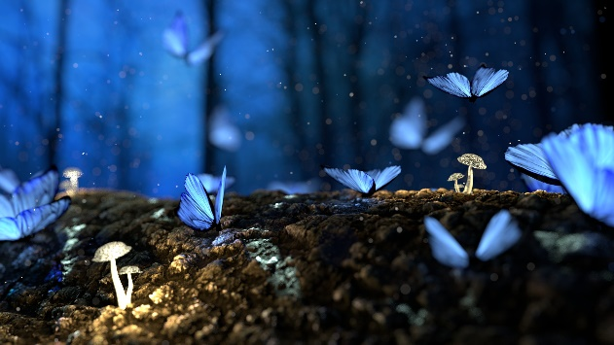

* + 1. https://www.pexels.com/photo/fireworks-display-1573707/
       1. beautiful-bright-celebrate-1573707.jpg



* + 1. https://www.pexels.com/photo/nature-forest-trees-park-38136/
       1. beautiful-bright-celebrate-1573707.jpg

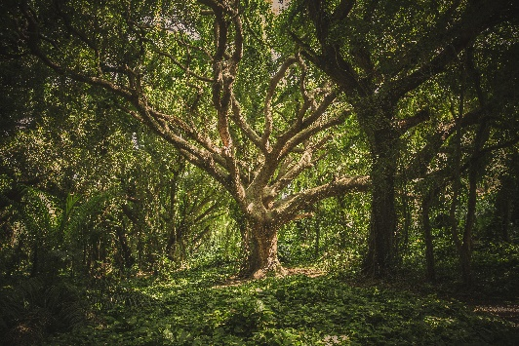

* + 1. https://www.pexels.com/photo/sunset-hands-love-woman-5390/
       1. beautiful-hands-heart-5390.jpg



* + 1. https://www.pexels.com/photo/u-s-dollar-bills-pin-down-on-the-ground-164474/
       1. bank-notes-blur-close-up-164474.jpg



* + 1. https://www.pexels.com/photo/aerial-photo-of-trees-1585724/
       1. aerial-shot-autumn-bird-s-eye-view-1585724.jpg

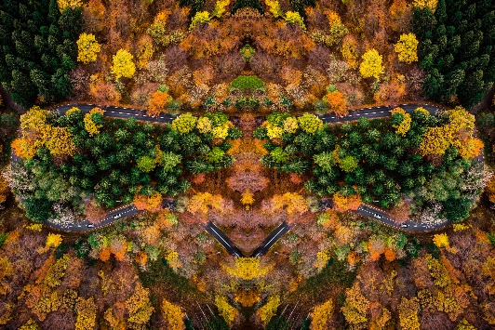

* + 1. https://www.pexels.com/photo/woman-wearing-fairy-costume-1545590/
       1. beautiful-butterfly-costume-1545590.jpg

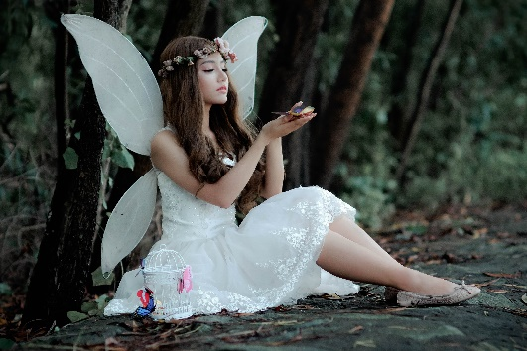

* + 1. https://www.pexels.com/photo/plant-dew-wet-flower-76963/
       1. bloom-blossom-close-up-76963 (1).jpg

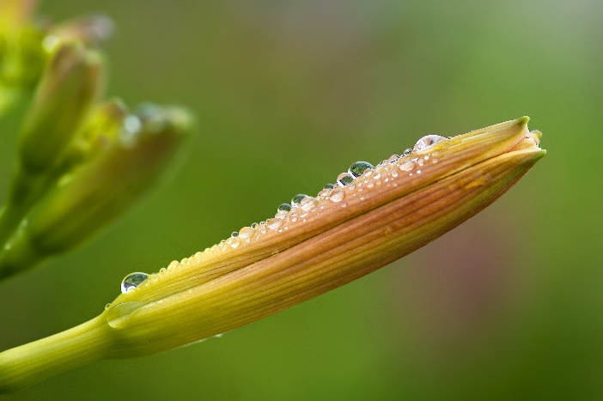

* + 1. https://www.pexels.com/photo/close-up-of-tree-against-sky-255441/
       1. art-background-blur-255441.jpg

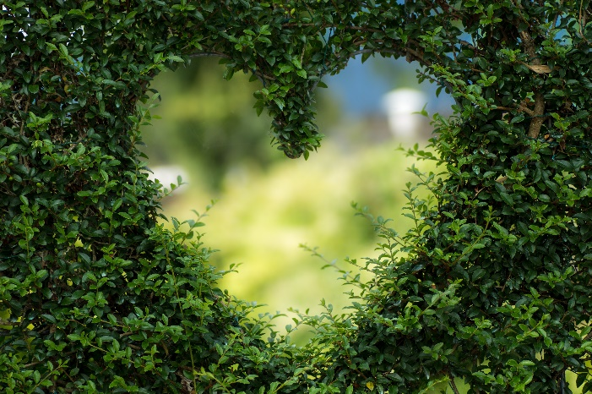

* + 1. https://www.pexels.com/photo/white-single-petaled-roses-closeup-photography-at-daytime-1125792/
       1. beautiful-bloom-blooming-1125792.jpg

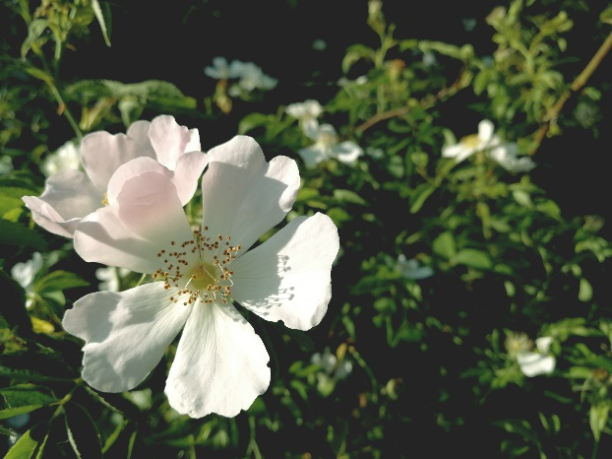

* + 1. accuracy-alarm-clock-analogue-552598.jpg/
       1. accuracy-alarm-clock-analogue-552598.jpg
       2. Photo by Mat Brown from Pexels



* + 1. https://www.pexels.com/photo/bird-animal-freedom-fly-56865/
       1. bird-bird-of-prey-eagle-56865.jpg

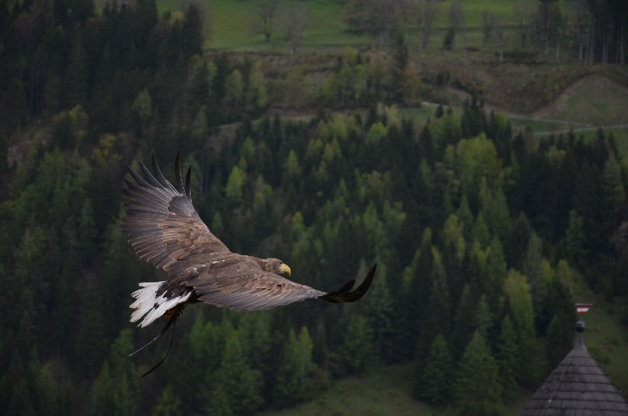

* + 1. https://www.pexels.com/photo/clear-light-bulb-planter-on-gray-rock-1108572/
       1. bright-bulb-close-up-1108572.jpg

Photo by Singkham from Pexels

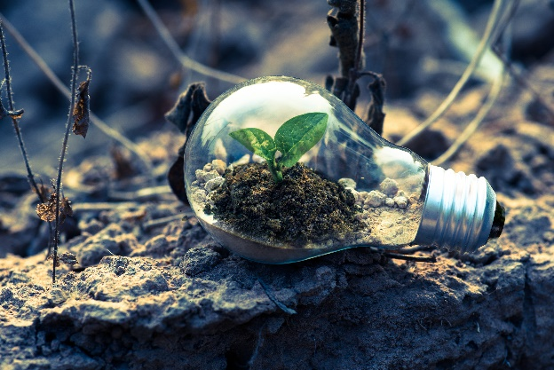

* + 1. https://www.pexels.com/photo/close-up-of-microscope-256262/
       1. bright-bulb-close-up-1108572.jpg

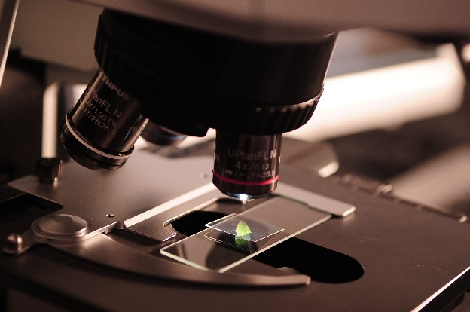

* + 1. https://www.pexels.com/photo/art-artistic-bright-color-220320/
       1. art-artistic-bright-220320.jpg



* + 1. animal-bright-bunny-372166.jpg
       1. animal-bright-bunny-372166.jpg

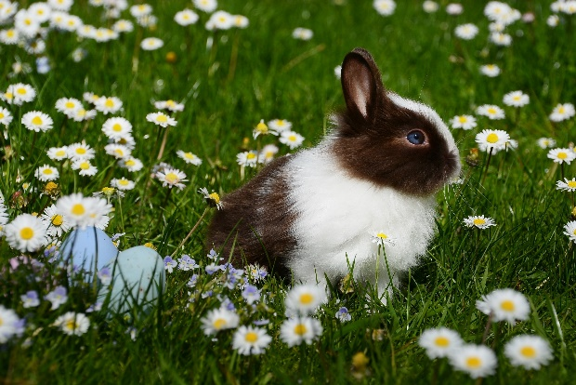

* + 1. https://www.pexels.com/photo/bloom-blooming-blossom-blur-458962/
       1. bloom-blooming-blossom-458962.jpg

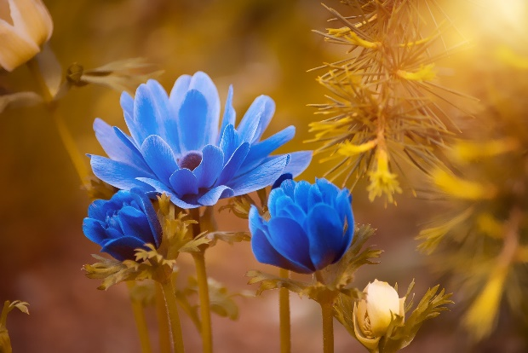

* + 1. https://www.pexels.com/photo/adorable-animal-animal-photography-blur-458976/
       1. adorable-animal-animal-photography-458976.jpg

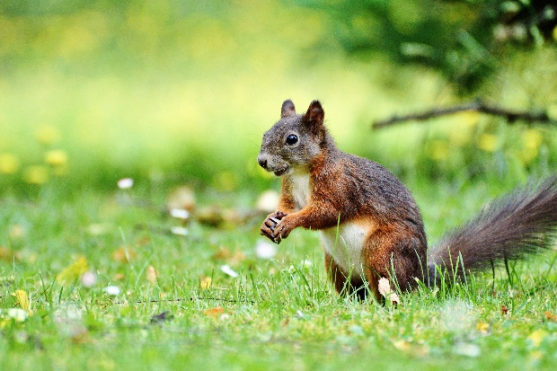

1. Pixabay
   1. CC0 License
   2. Free for personal and commercial use
   3. ✓ No attribution required
      1. backlight-fern-green-37398.jpg
         1. backlight-fern-green-37398.jpg

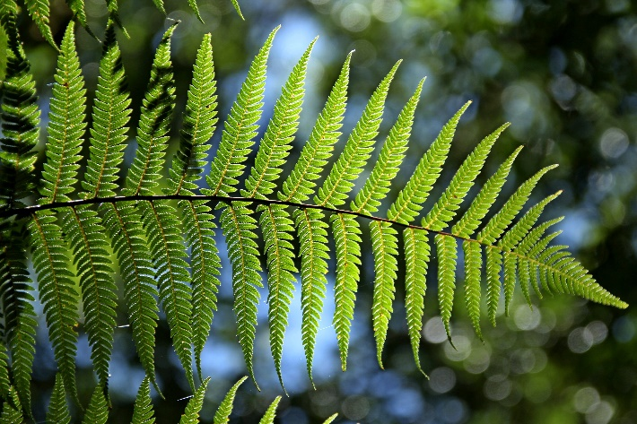

* + 1. https://www.pexels.com/photo/nature-yellow-plant-leaves-48190/
       1. autumn-branch-colorful-48190.jpg

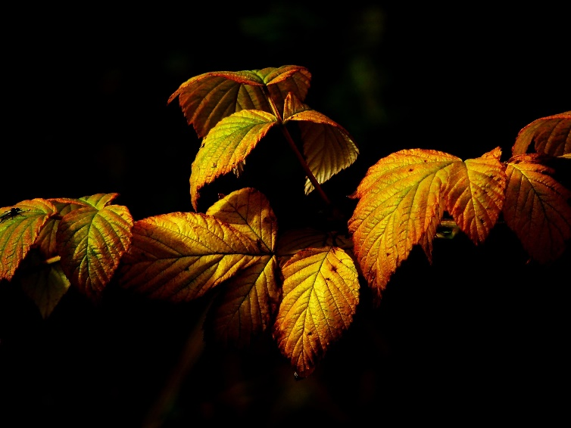

**Icon Licenses**

1. Font Awesome 5
   1. Font Awesome is fully open source and is GPL friendly. You can use it for commercial projects, open source projects, or really just about whatever you want.
   2. Attribution is no longer required as of Font Awesome 3.0 but is much appreciated: "Font Awesome by Dave Gandy - <http://fontawesome.io>".
      1. Font License
         1. Applies to all desktop and webfont files in the following directory: font-awesome/fonts/.
         2. License: SIL OFL 1.1
         3. URL: <http://scripts.sil.org/OFL>